## Line Plot of Crime by Category

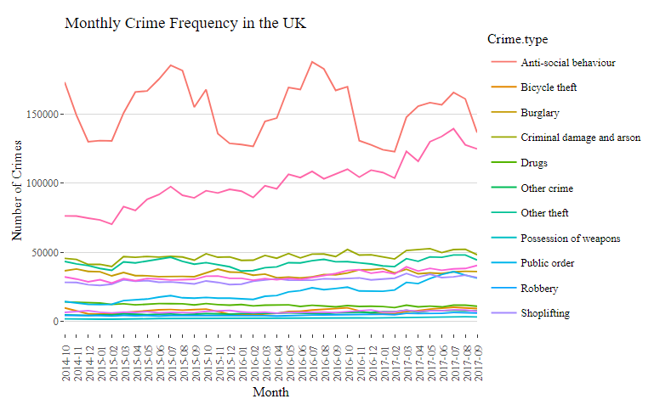

## Top Changes in Crime Categories (2014-2017)

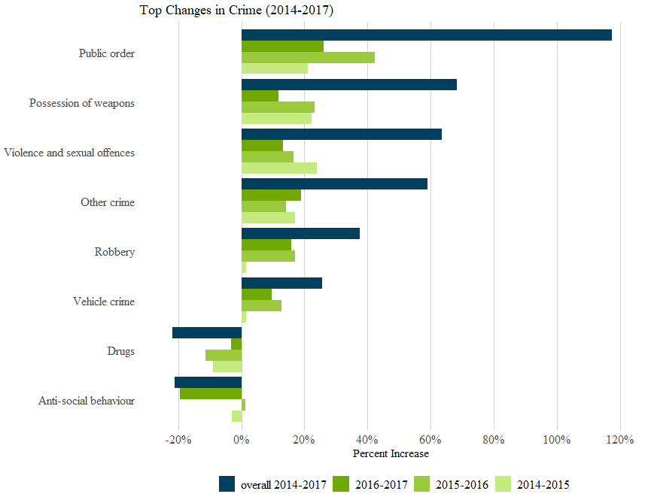

## Anti-Social Behavior Seasonality

I’m not sure if there’s an obvious regional trend with regards to which regions are more affected, except that regions that already were darker seem to be a bit more affected. There is a pattern with sesasons, though. The summer months look more red because there is more ASB. What do you think? I removed the labels here to see colors better but if you want to know what the regions are, you can look at the choropleth map of all the UK crime later on in this document.

All graphs are crimes per thousand, and here’s the legend:

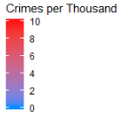

January 2015 July 2015

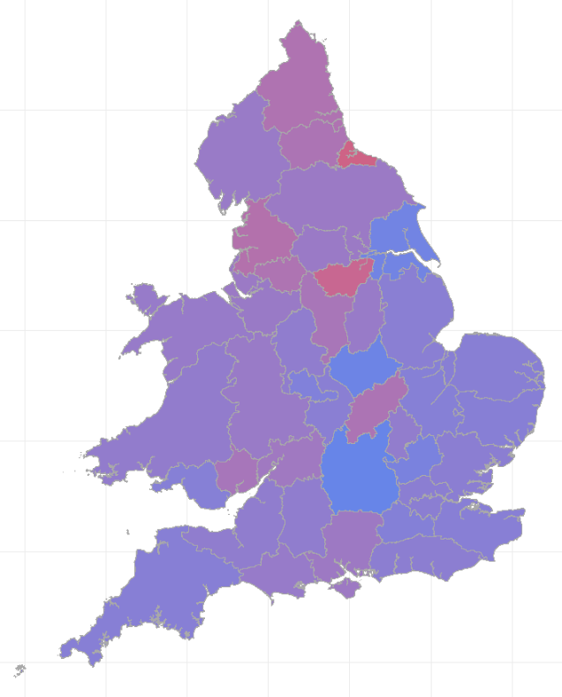 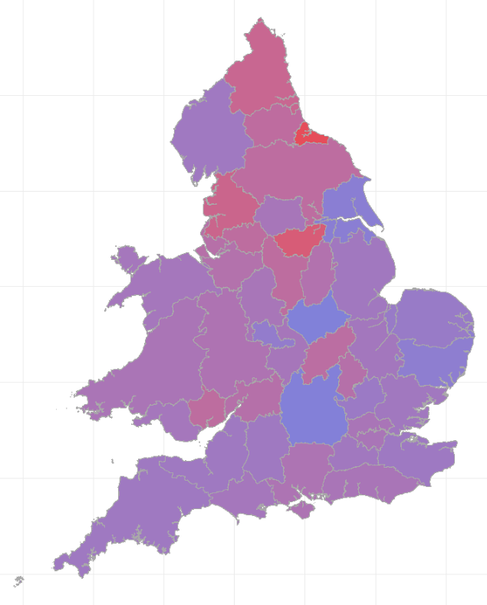

January 2016 July 2016

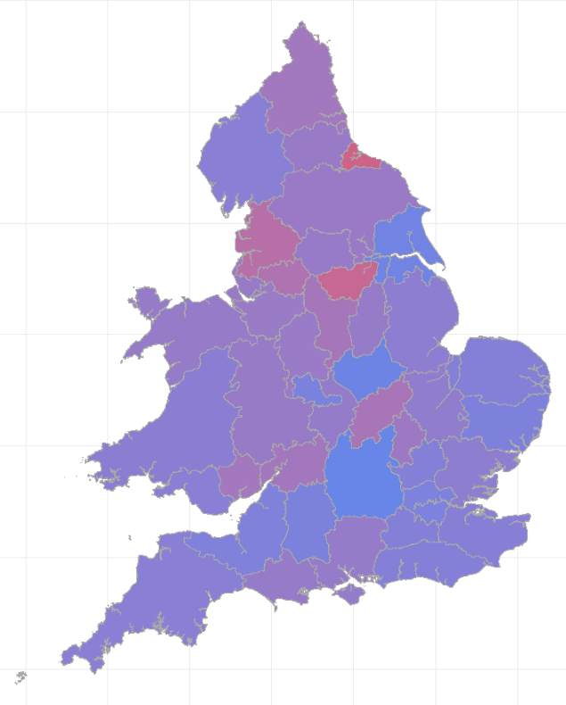 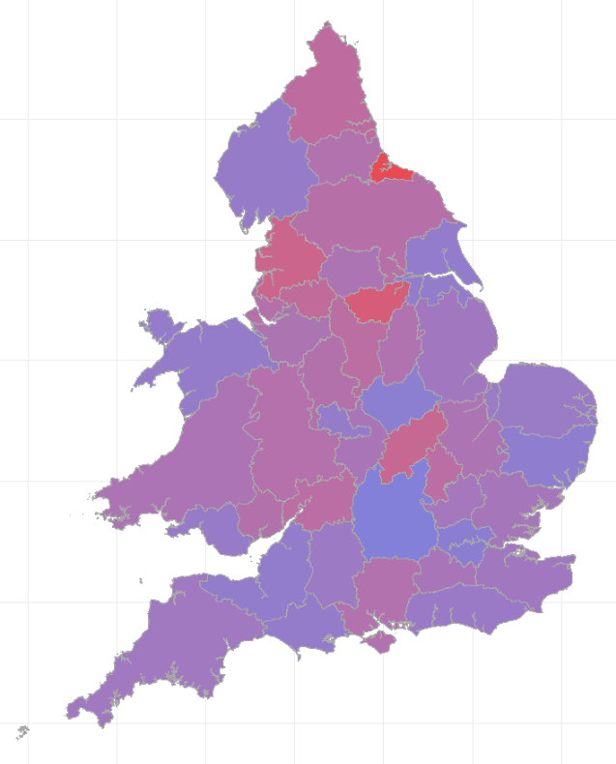

## Bike Theft Seasonality

Can you look into Cambridgeshire’s bike theft problem? It’s the reddest one here and has such a high rate of bike theft that it’s about twice the rate as the next highest, especially in July 2017. And it’s not a high crime region in general. Here one article I found: <https://www.cambridge-news.co.uk/news/cambridge-news/bike-thefts-cambridge-station-police-16794016>

These maps all share this scale:



January 2015 July 2015

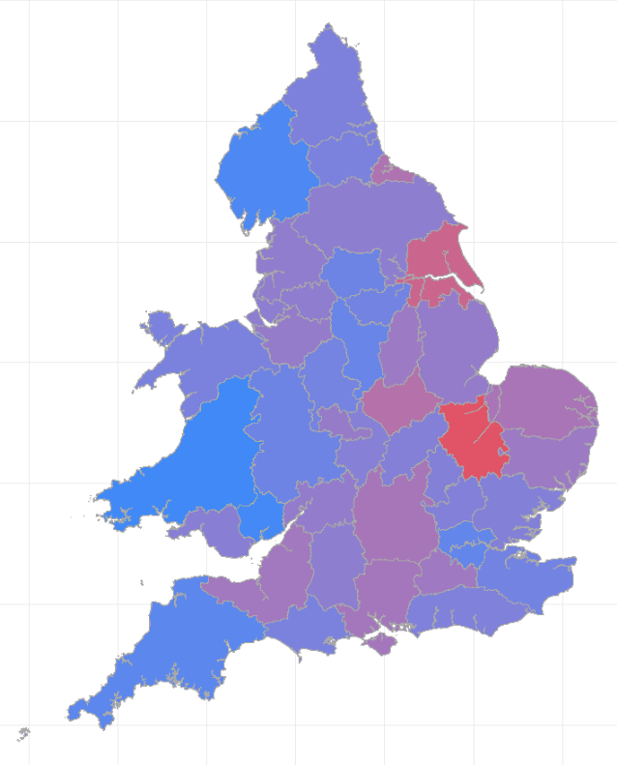 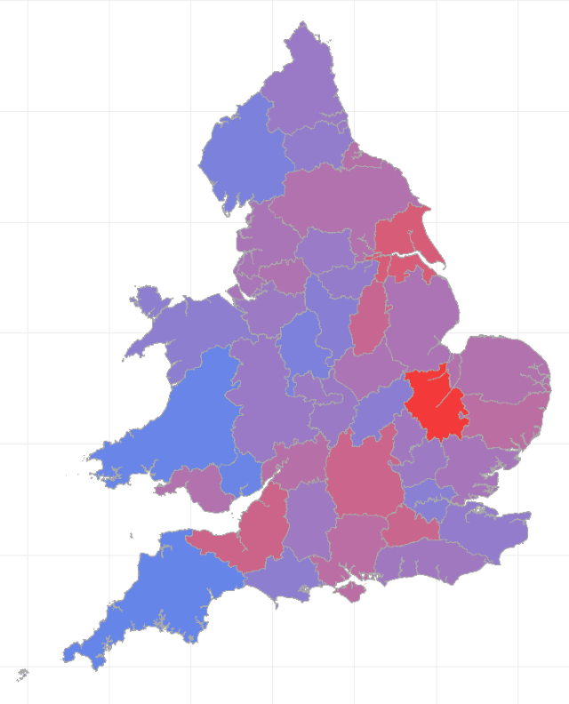

January 2016 July 2016

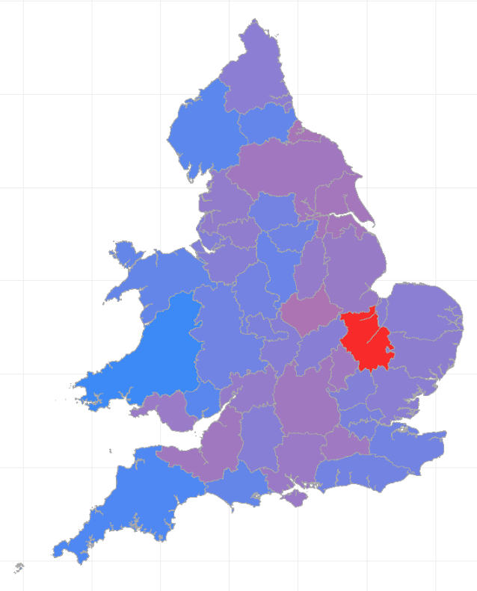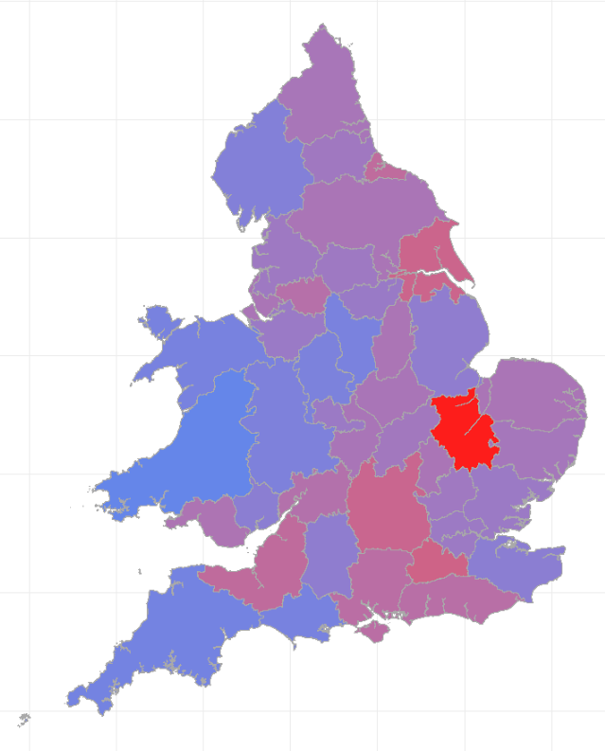

## Public Order 2014-2017

Looks like there are a couple of areas are most affected by an increase in public order. For example, Greater Manchester and Northumbria might be worth looking in to.

October 2014

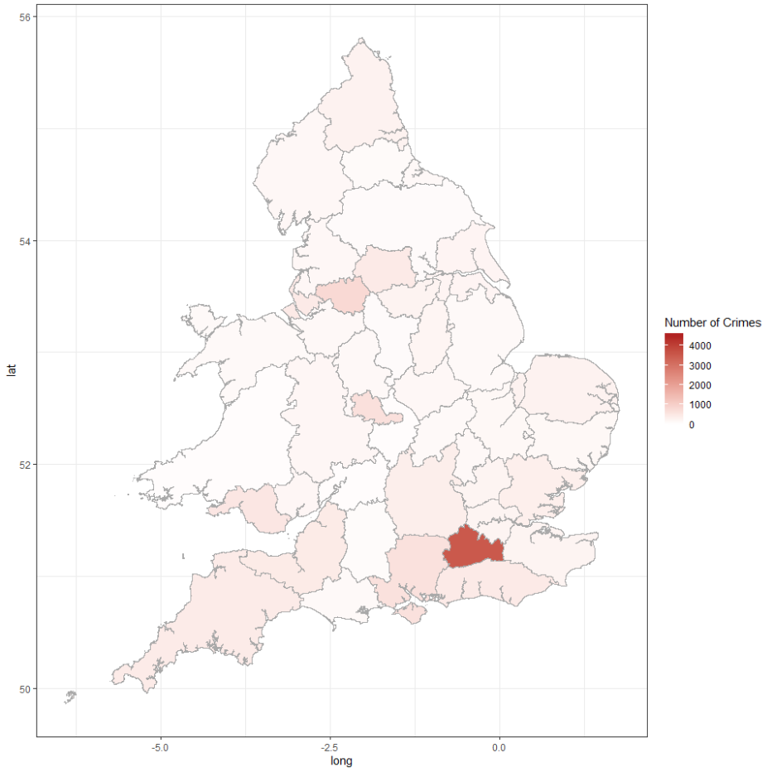

September 2017

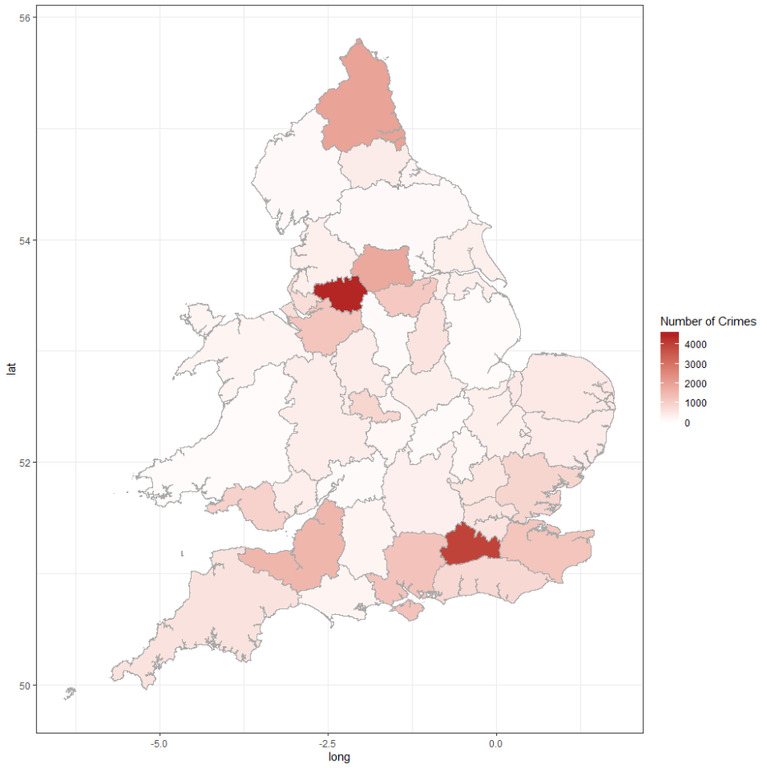

## Possession of Weapons 2014-2017

Looks like the Metropolitan Police and Hertfordshire were most affected by an increase in possession of weapons.

October 2014

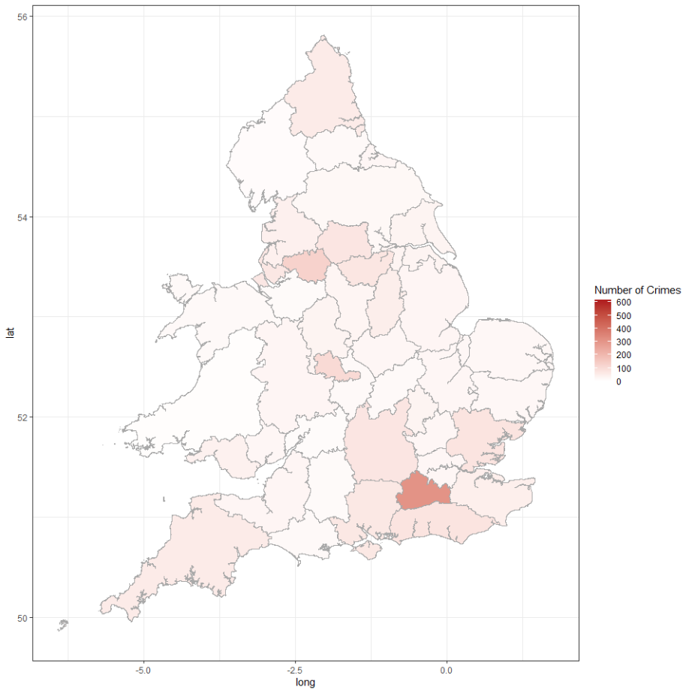

September 2017

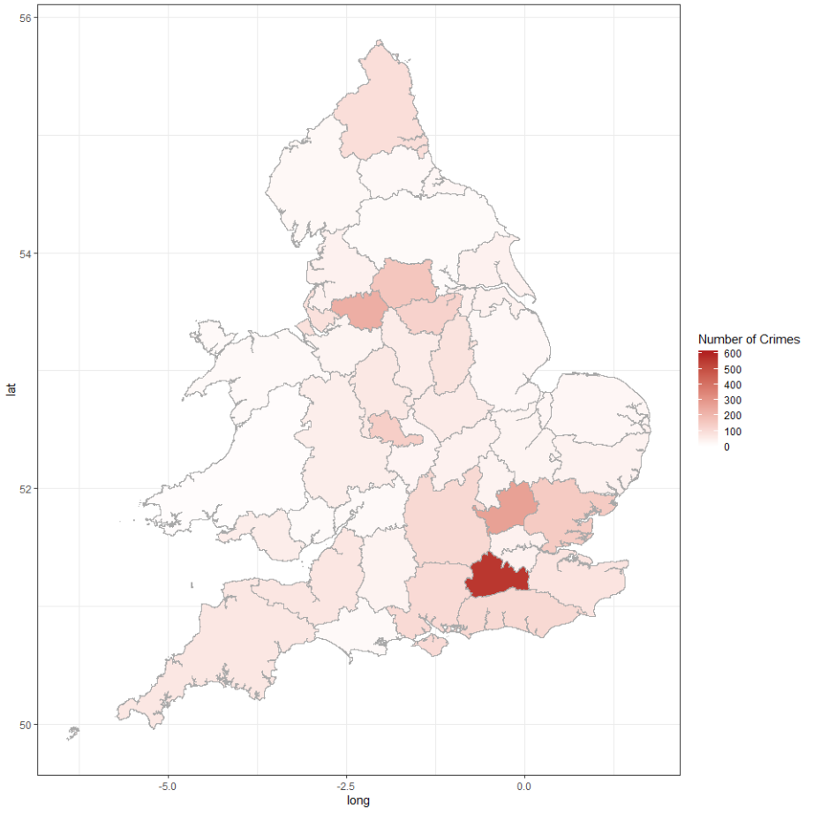

## Choropleth Maps of Crime Rate of the UK (2016)

Map 1 shows that most places seem to have about more or less the same crime rates, but actually if we zoom in on London in Map 2, we see that London has a much higher crime rate (747/thousand). That’s why the variation between the other regions are relatively insignificant in comparison to London.

But if we remove the outlier that is the city of London, we can see other regional variations more clearly in Map 3. Note that the scale changes from up to 800 to up to 100 because the crime rate for these regions are no more than 100 per thousand.

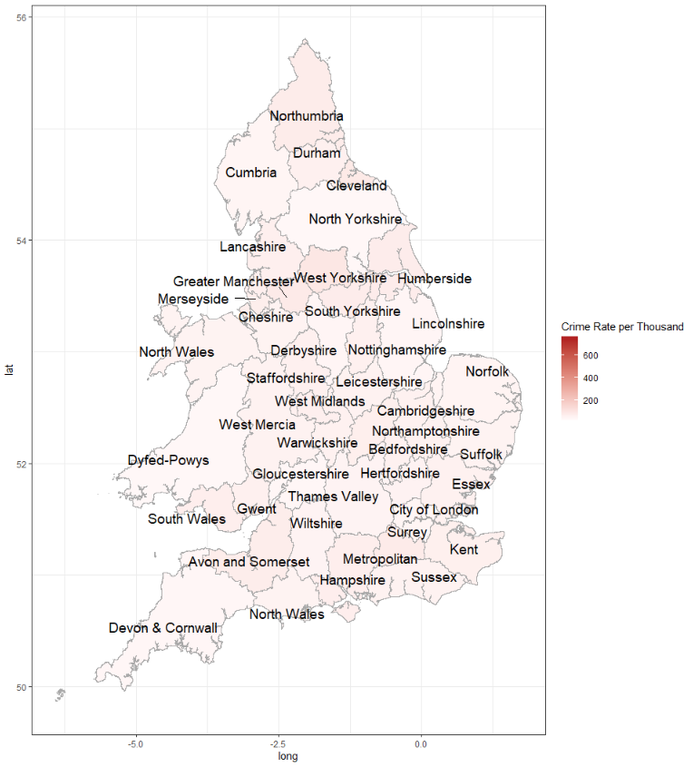

### Choropleth Map of crime rate of London

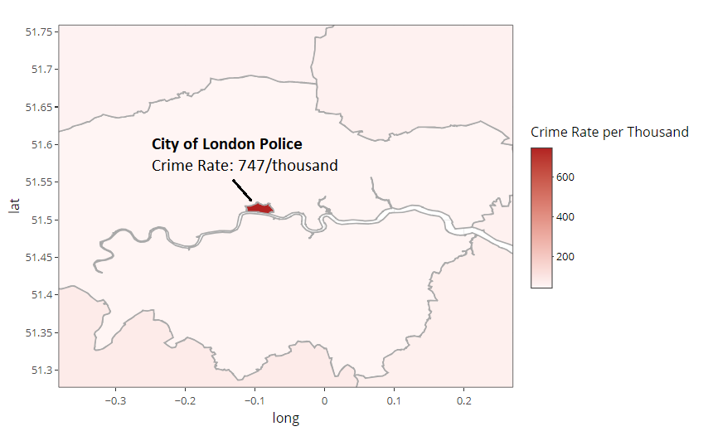

### Choropleth Map of crime rate of the UK (excluding London)

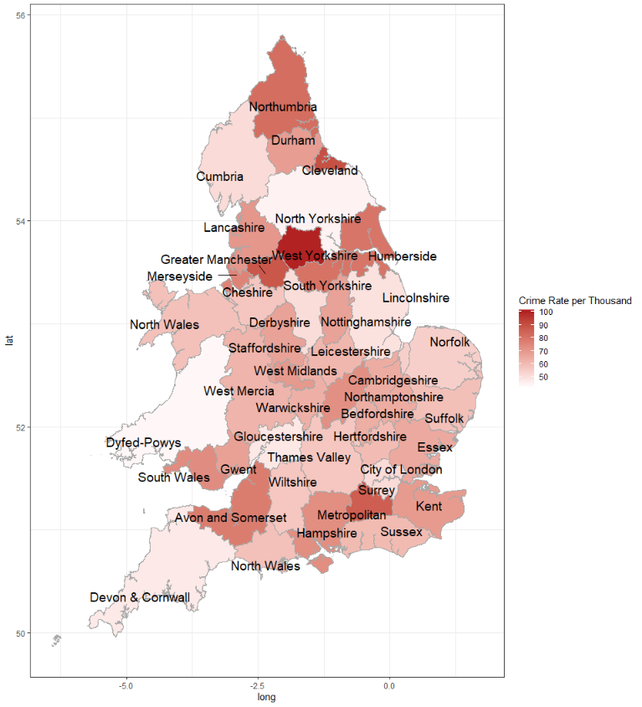

## Westminster Attack

I looked again at where the Westminster attacks happened to see if ASB would be different from Feb to March, and there was not much difference.

February 2017 map:

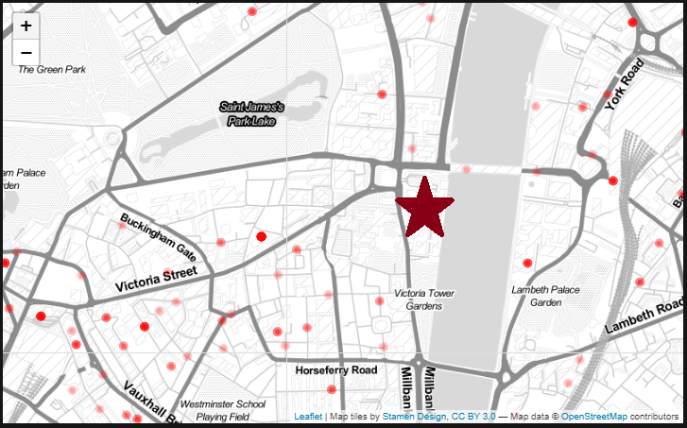

March 2017 map:

